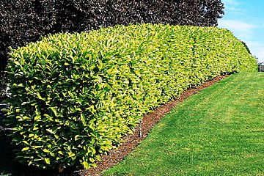
Angelique Craughan
English Laurel AKA Cherry Laurel
(Prunus laurocerasus)

Description (1,2,3)
(3)
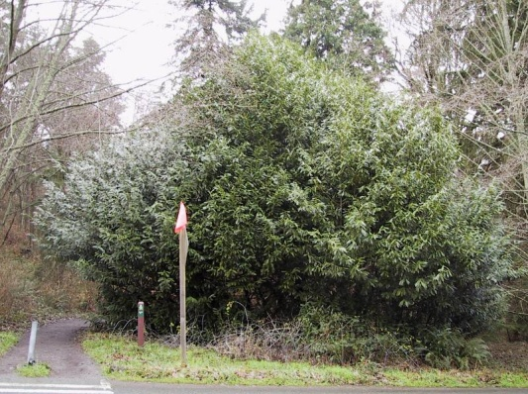
- Evergreen shrub/tree can grow up to 50ft tall if not maintained
- Leaves are dark on top and light on bottom, oblong shaped w/ fine toothed serrated edge
- Produces shoots of flower clusters in spring that resemble cherry flowers, they have 5 petals and are cup shaped
- Produces small and fleshy fruit that is dark purple when mature, this fruit has a large pit and grows in clusters
- Twigs are green and smooth
(1)
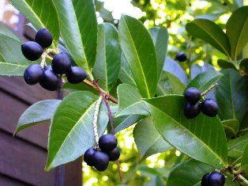
- Poisonous parts include wilted leaves, stems, and the fruit seeds can be fatal if eaten in quantity

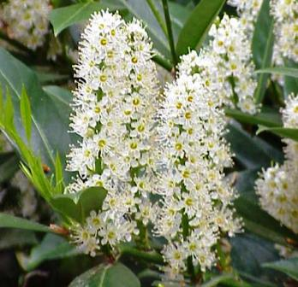
English laurel also called cherry laurel and is not from England but is called this due to its resemblance to the laurel tree. It is native to the regions bordering the Black Sea in southwestern Asia and southeastern Europe and has been widely introduced in Europe and North America as an ornamental hedge. It is common in urban areas and is known to escape cultivated areas and to get into urban forested areas and can also be found in some rural areas. It is prevalent in the on the West coast and can be found throughout California, Oregon, Washington, and British Columbia. The economic impact of this plant is unknown while the environmental impact is in the loss of room for native trees and shrubs to grow.
(3)

Reproduction and Spread (1)
- Seeds distributed by birds (bird poop) and possibly other animals
- Also spreads by growing roots from stems that touch the ground
- English Laurel can also re-grow from clippings
- Prefers moist, well-drained soils and can grow in sun or shade

Control (1)
(3)
- Small plants can be dug up from moist soil
- Larger plants can be controlled by cutting them down to the ground and the branches and other debris sent through a wood chipper and used as mulch or sent to a landfill. If the debris is chip then there shouldn’t be a problem with re-rooting.
- Re-growth is possible after being cut down

Control Re-growth (1)
- Dig out as much of the stump as possible and brush off dirt from roots. If there is a large area covered by this plant it may not be possible to do this option.
- Monitor area for re-growth and break off or dig up any ne shoots or plantings. This should be done regularly throughout the growing season for several years until the plant stops sending out new shoots
- An herbicide like triclopyr or glyphosate can be used by being sprayed on the cut stems or being injected into the plant. When doing this method the product label should be read carefully and followed. Herbicides may not be allowable in all locations, so contact your local government office about permit requirements or restrictions.

Interesting Facts (3)
- A green dye can be obtained from the leaves and a dark grey dye can be obtained from the fruit.
- Fresh leaves from English laurel are reported to be an antispasmodic, narcotic and a sedative. They are said to be of value in the treatment of coughs, whooping cough, asthma, dyspepsia and indigestion. Externally, a cold infusion of the leaves is used as a wash for eye infections. There are different opinions as to the best time to harvest the leaves, but they should only be used fresh because the active principles are destroyed if the leaves are dried.
- Symptoms of English Laurel poisoning are gasping, weakness, excitement, pupil dilation, spasms, convulsions, coma, respiratory failure.
- HIGHLY TOXIC, MAY BE FATAL IF EATEN!

Sources
- "English Laurel." Noxious Weeds King County, Washington. King County, Washington, 12 Aug 2010. Web. 16 Aug 2010. <http://www.kingcounty.gov/environment/animalsAndPlants/noxious-weeds/weed-identification/english-laurel.aspx>.
- "English Laurel." Plant Profile. USDA Natural Resources Conservation Service , n.d. Web. 16 Aug 2010. <http://plants.usda.gov/java/profile?symbol=PRLA5>.
- "ENGLISH LAUREL." Fruitipedi. Fruitipedi, n.d. Web. 16 Aug 2010. <http://www.fruitipedia.com/english_laurel_prunus_laurocerasus.htm>.

